John Smith Module 2.3_ Data Model 1/19/2025

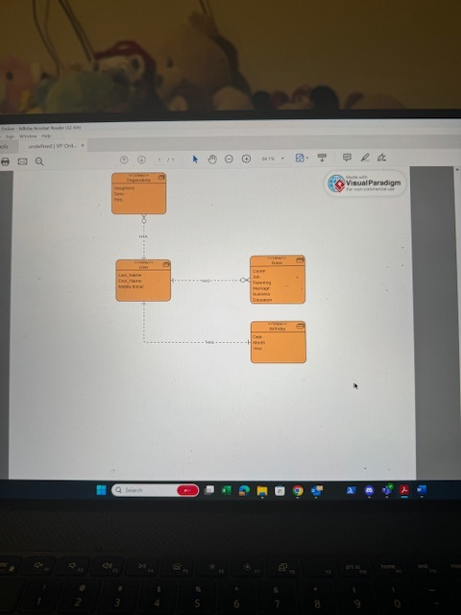

**NoSQL Data Structure**

User: {“Last_Name”, “First_Name”, “Middle Initial”}

Roles: {“Career”, “Job”, “Parenting”, “Marriage”, “Business”, “Education”}

Birthday: {“Date”, “Month”, “Year”}

Dependents: {“Daughters”, “Sons”, “Pets”}